**5 Google Ads Success Stories that Inspire Your Next Campaigns**

**1. Ras Car Care Mobile Detailing: Capturing Unbranded Traffic**

**Company Background**

Ras Car Care LLC, founded in 2022 by a former Mercedes-Benz executive, is a US-based direct-to-consumer service delivery business that sells detailing service in and around Raleigh NC

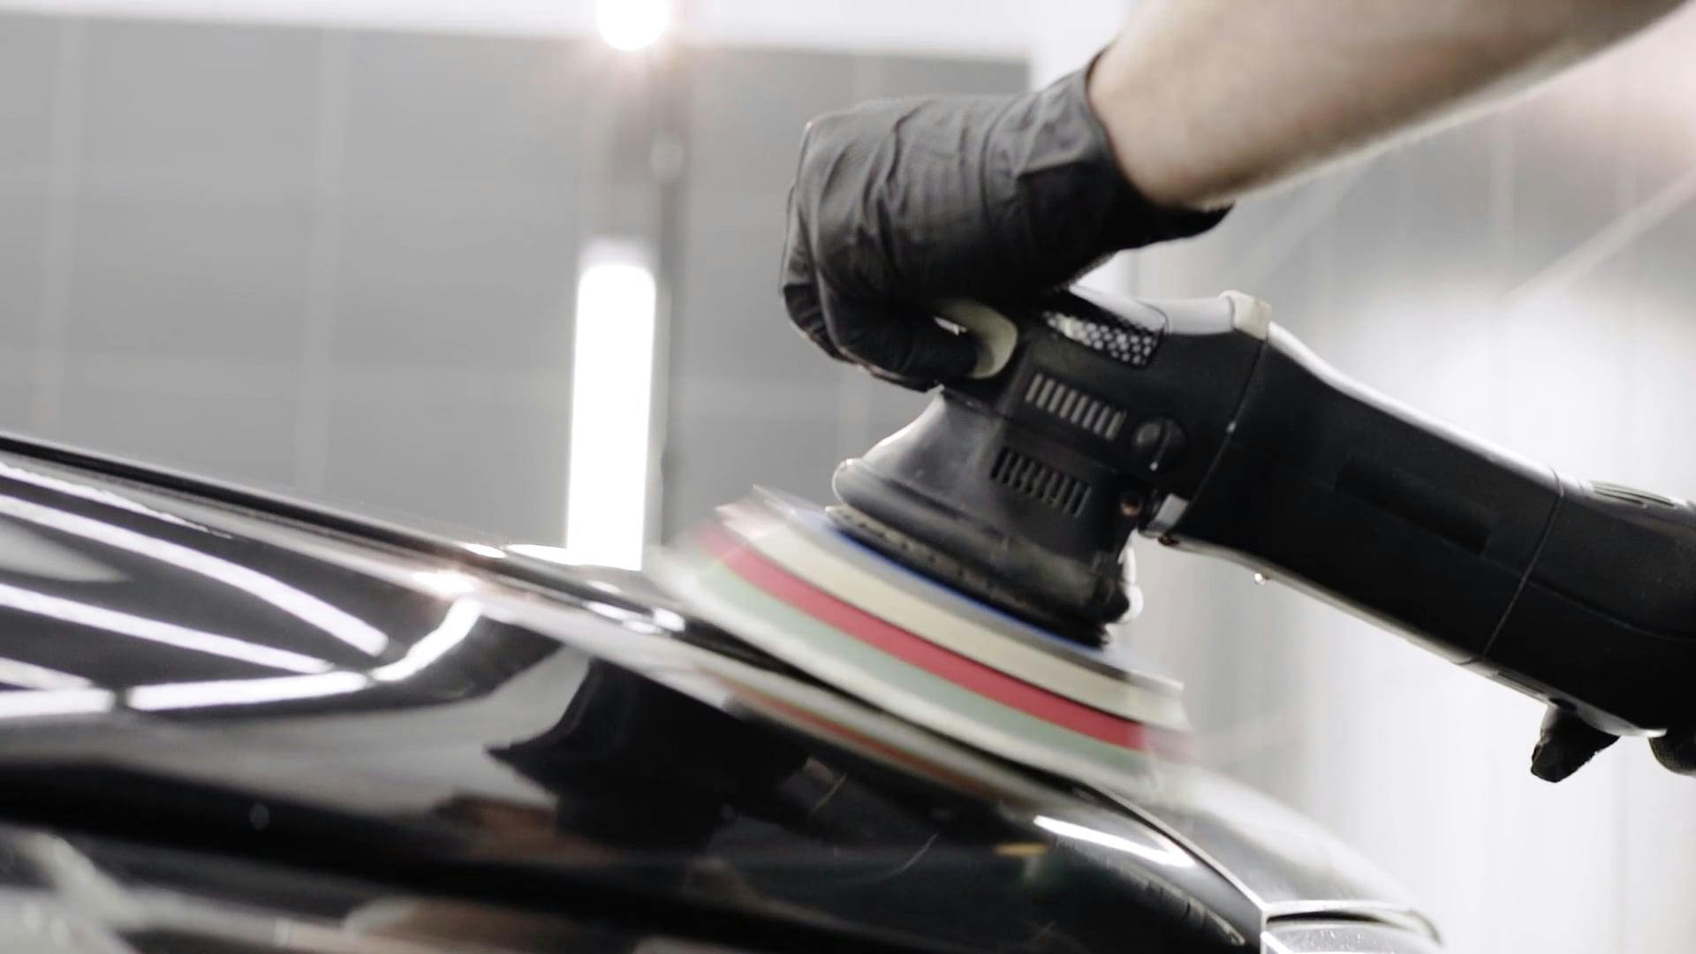

As a new player in the market, Ras Car Care faced the challenge of increasing brand awareness and capturing a significant share of the market. They needed a strategy to introduce their services to a wide audience of potential customers and drive awareness and consideration for their products and services.

**How Google Ads helped?**

Google Ads was chosen as the platform for its ability to reach a large audience and its features that allow for targeted and effective advertising. Specifically, Ras Car Care. leveraged Google Ads to capture unbranded search traffic, which refers to searches where users are looking for a car detailing products or services but have not specified a brand in their search query.

| Keyword | Monthly searches | CPC |
| --- | --- | --- |
|  | 1,000 | $2.18 |
| carry on luggage | 90,500 | $1.94 |
| suitcase | 90,500 | $1.86 |
| luggage sets | 74,000 | $1.98 |

Source: [Semrush](https://www.semrush.com/" \t "_blank)

By using Google Ads, Away Travel was able to capture a significant volume of unbranded search traffic. This strategy allowed them to introduce their brand to a wide audience of potential customers, driving awareness and consideration for their products.

The search ads Away uses for unbranded searches are very similar to the ones for branded traffic.

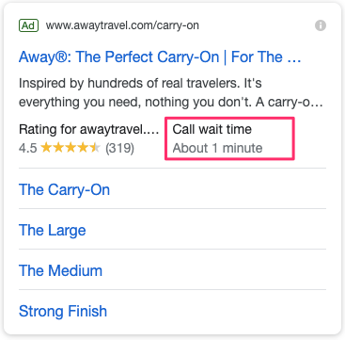

They are also using the ® hack to increase CTR, a trick that often works.

Besides the ad, they are using all ad extensions: everything from site links, callouts, structured snippets, seller ratings, and even a new type of call extension.

**Results**

About 70% of all Search Ads clicks for Away, worth about $35,000 per month, come from unbranded paid search. Across all campaigns, they achieved an average click-through rate (CTR) of 4.3%, significantly exceeding industry benchmarks.